Question 1 - Table creation -

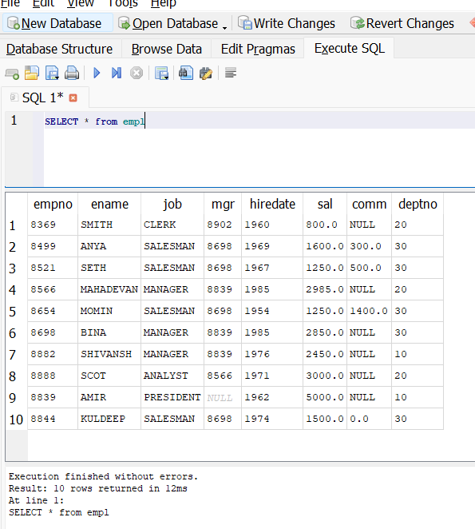

A - Query to display ename and salary of employee whose salary is >=2200

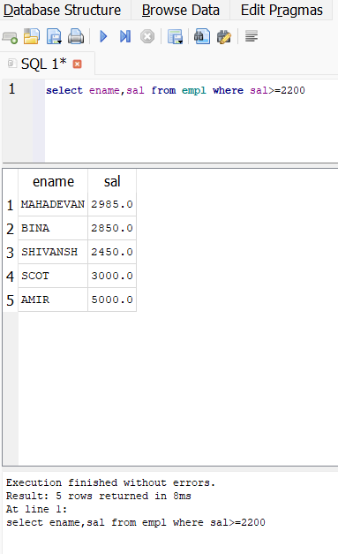

B - Query to display details of employees who are not getting commission

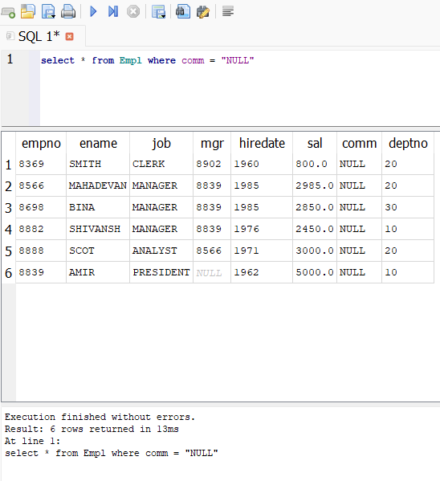

C - ename and salary whose do not have salary in range of 2500 to 4000

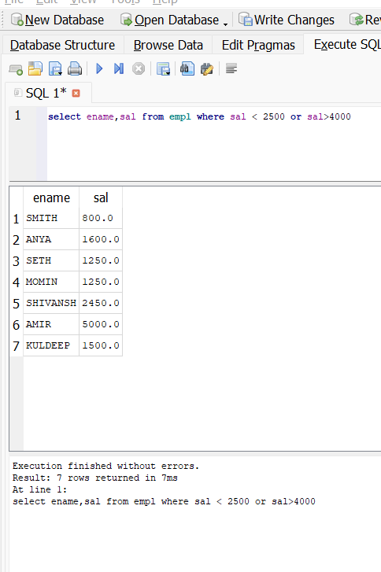

D - Dislay name, Job and salary whose job is not manager

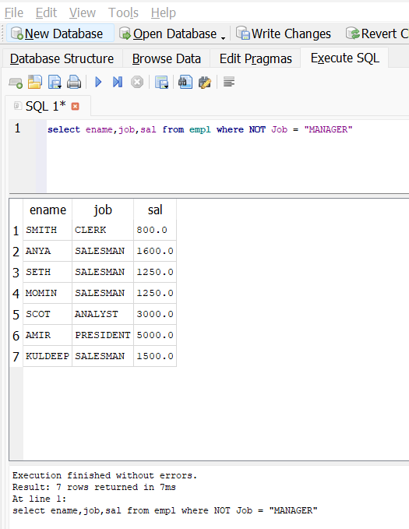

E - Display the name of employee whose name contains “A” as third alphabet

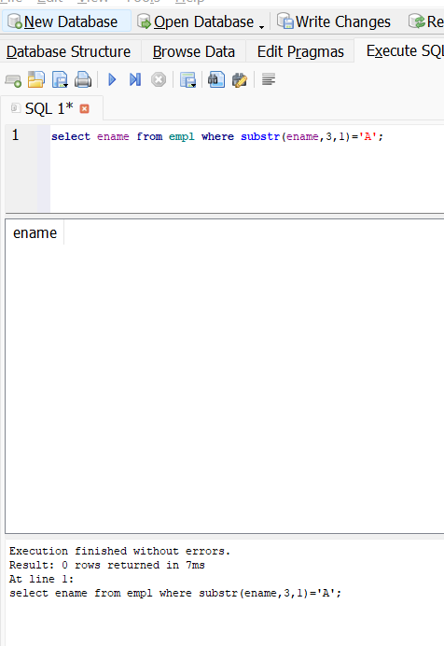

F - Display the name of employee whose name contains “T” as Last alphabet

